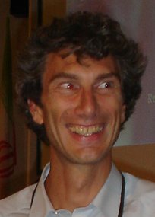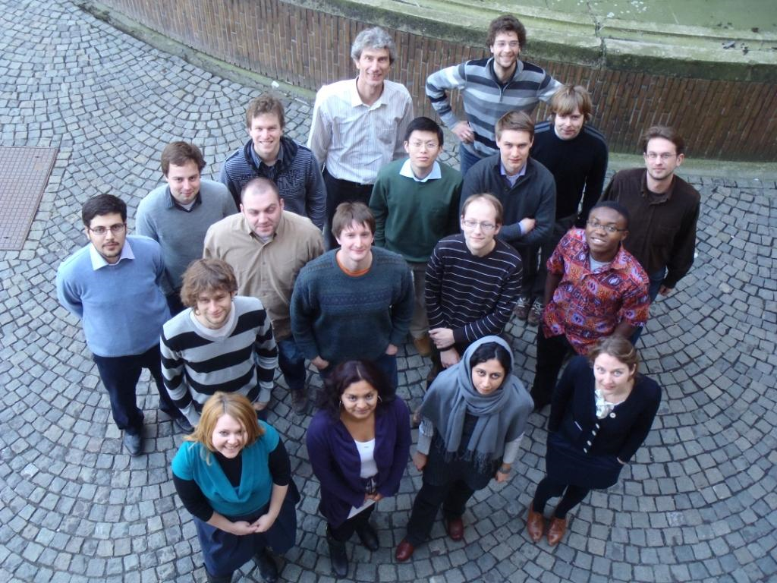

Kristiaan Neyts is a full research professor at Ghent University, in the ELIS department (www.elis.ugent.be) of the faculty of Engineering and Architecture.
He is heading the Liquid Crystals and Photonics group that is conducting research in the fields of liquid crystals, OLEDs and electrophoresis. This group of 18 researchers has expertise in device technology, numerical simulations and electro-optical characterization. The web site of the group is http://lcp.elis.ugent.be.
Kristiaan Neyts is co-author of over 100 journal papers listed in the web of science. He made his PhD in the field of thin film electroluminescence in 1987 and is now involved in research projects in basic and applied research, in collaboration with universities and companies worldwide.

His main research results are in the following fields:
- light propagation in structured anisotropic media
- spatial optical solitons in liquid crystals
- light emission from thin film structures and OLEDs
- electrophoresis in non-polar media
- optics of lighting and displays.

A few current projects:

- FINELUMEN - EU Integrated Training Network
- OLED1000 - EU project on OLEDs. See the related EuroNews TV program
- photonics@be - sponsored by the Belgian Science Policy.

Recent publications of Neyts, K
- Saso Mladenovski, Sebastian Reineke, Lieven Penninck and Kristiaan Neyts. Detailed analysis of exciton-decay-time change in organic light-emitting devices caused by optical effects. JOURNAL OF THE SOCIETY FOR INFORMATION DISPLAY. Vol. 19. 2011. 80-86.
- Jeroen Beeckman, Kristiaan Neyts and Pieter Vanbrabant. Liquid-crystal photonic applications. OPTICAL ENGINEERING. Vol. 50. 2011. 17
- Pieter Vanbrabant, Jeroen Beeckman, Kristiaan Neyts, Richard James and F Anibal Fernandez. Finite element optical modeling of liquid crystal waveguides. OPTICAL ENGINEERING. Vol. 50. 2011. 7.
- Kristiaan Neyts, Wout De Cort, Hamidreza Azarinia, Pieter Vanbrabant, Richard James and Jeroen Beeckman. Liquid crystals in waveguides for tuning and sensing. PHOTONICS LETTERS OF POLAND. Vol. 3. 2011. 17-19.
- Saso Mladenovski, Simone Hofmann, Sebastian Reineke, Lieven Penninck, Thomas Verschueren and Kristiaan Neyts. Integrated optical model for organic light-emitting devices. JOURNAL OF APPLIED PHYSICS. Vol. 109. 2011. 083114-1-083114-9.
- Filip Strubbe, Pieter Vanbrabant, Filip Beunis, Bart Verboven, Masoumeh Karvar and Kristiaan Neyts. In-plane electrophoresis in nonpolar liquids : measurements and simulations. COLLOIDS AND SURFACES A-PHYSICOCHEMICAL AND ENGINEERING ASPECTS. Vol. 376. 2011. 89-96.
- Andreas Georgiou, Jeroen Beeckman and Kristiaan Neyts. Multicasting optical interconnects using liquid crystal over silicon devices. JOURNAL OF THE OPTICAL SOCIETY OF AMERICA A-OPTICS IMAGE SCIENCE AND VISION. Vol. 28. 2011. 363-372.
- Wout De Cort, Jeroen Beeckman, Richard James, F Anibal Fernandez, Roel Baets and Kristiaan Neyts. Tuning silicon-on-insulator ring resonators with in-plane switching liquid crystals. JOURNAL OF THE OPTICAL SOCIETY OF AMERICA B-OPTICAL PHYSICS. Vol. 28. 2011. 79-85.
- Pieter Vanbrabant, Jeroen Beeckman, Kristiaan Neyts, Richard James and F Anibal Fernandez. Optical analysis of small pixel liquid crystal microdisplays. JOURNAL OF DISPLAY TECHNOLOGY. Vol. 7. 2011. 156-161.
- Slawomir Ertman, Thomas R Wolinski, Jeroen Beeckman, Kristiaan Neyts, Pieter Vanbrabant, Richard James and Anibal F Fernandez. Numerical Simulations of Electrically Induced Birefringence in Photonic Liquid Crystal Fibers. ACTA PHYSICA POLONICA A. Vol. 118. 2010. 1113-1117.
- Filip Beunis, Filip Strubbe, Matthias Marescaux, Kristiaan Neyts and Alwin RM Verschueren. Micellization and adsorption of surfactant in a nonpolar liquid in micrometer scale geometries. APPLIED PHYSICS LETTERS. Vol. 97. 2010. 3.
- Pieter Vanbrabant, Jeroen Beeckman, Kristiaan Neyts, Eero Willman and F. Anibal Fernandez. Diffraction and fringing field effects in small pixel liquid crystal devices with homeotropic alignment. JOURNAL OF APPLIED PHYSICS. Vol. 108. 2010. 6.
- Jeroen Beeckman, Kristiaan Neyts, Pieter Vanbrabant, Richard James and F Anibal Fernandez. Finding exact spatial soliton profiles in nematic liquid crystals. OPTICS EXPRESS. Vol. 18. 2010. 3311-3321.
- Lieven Penninck, Saso Mladenovski and Kristiaan Neyts. The effects of planar metallic interfaces on the radiation of nearby electrical dipoles. JOURNAL OF OPTICS. Vol. 12. 2010. 8.
- Jeroen Beeckman, David P Medialdea, Tian Hui, Kristiaan Neyts and Xabier Quintana. Fast visible-near infrared switchable liquid crystal filter. MOLECULAR CRYSTALS AND LIQUID CRYSTALS. Vol. 502. 2009. 9-18.
- Jeroen Beeckman, Tian Hui, Pieter Vanbrabant, Robert Zmijan and Kristiaan Neyts. Polarization selective wavelength tunable filter. MOLECULAR CRYSTALS AND LIQUID CRYSTALS. Vol. 502. 2009. 19-28.
- Pieter Vanbrabant, Jeroen Beeckman and Kristiaan Neyts. Tunable quasi-homeotropic liquid crystal pretilt angle based on competing alignment layers. LIQUID CRYSTALS. Vol. 36. 2009. 1373-1377.
- Wout De Cort, Jeroen Beeckman, Richard James, F Anibal Fernandez, Roel Baets and Kristiaan Neyts. Tuning of silicon-on-insulator ring resonators with liquid crystal cladding using the longitudinal field component. OPTICS LETTERS. Vol. 34. 2009. 2054-2056.
- Saso Mladenovski, Sebastian Reineke and Kristiaan Neyts. Measurement and simulation of exciton decay times in organic light-emitting devices with different layer structures. OPTICS LETTERS. Vol. 34. 2009. 1375-1377.
- Pieter Vanbrabant, Jeroen Beeckman, Kristiaan Neyts, Richard James and F Anibal Fernandez. Effect of material properties on reverse flow in nematic liquid crystal devices with homeotropic alignment. APPLIED PHYSICS LETTERS. Vol. 95. 2009. 151108-1-151108-3.
- Hamidreza Azari Nia, Jeroen Beeckman, Kristiaan Neyts, Etienne Schacht, Jordi Giron??s Molera, Richard James and F An??bal Fern??ndez. Orientation of nematic liquid crystal in open glass microstructures. JOURNAL OF APPLIED PHYSICS. Vol. 106. 2009.
- Saso Mladenovski, Kristiaan Neyts, Domagoj Pavicic, Ansgar Werner and Carsten Rothe. Exceptionally efficient organic light emitting devices using high refractive index substrates. OPTICS EXPRESS. Vol. 17. 2009. 7562-7570.
- Pieter Vanbrabant, Jeroen Beeckman, Kristiaan Neyts, Richard James and F. Anibal Fernandez. A finite element beam propagation method for simulation of liquid crystal devices. OPTICS EXPRESS. Vol. 17. 2009. 10895-10909.
- Jeroen Beeckman, Richard James, F Anibal Fernandez, Wout De Cort, Pieter Vanbrabant and Kristiaan Neyts. Calculation of fully anisotropic liquid crystal waveguide modes. JOURNAL OF LIGHTWAVE TECHNOLOGY. Vol. 27. 2009. 3812-3819.
- Jeroen Beeckman, Tian Hui, Pieter J.M. Vanbrabant, Robert Zmijan and Kristiaan Neyts. Polarization Selective Wavelength Tunable Filter. Molecular Crystals and Liquid Crystals. Vol. 502. 2009. 19-28.

